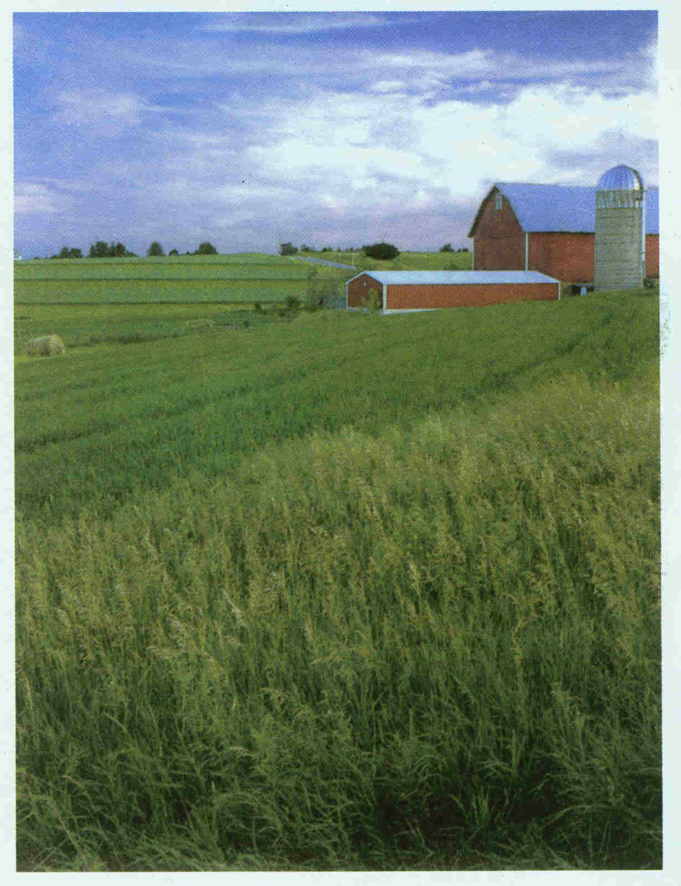

ONE LAST LOOK

One last look at the rain gauge, the bottom’s covered with dust.
One last look at the heavens. Can’t see a cloud he can trust.

Far off sheets of heat lightening play tricks on the cowman’s mind.
Bearing false witness they tease, leaving mirages behind.

“Good Lord! Don’t it ever end!
I’m sick to death of this drought.
One more year like the last one
And I might as well sell out.

Heck, I’ve sold off half my cow herd
Still feedin’ the others hay.
Nothin’s green in the pasture.
I keep lookin’ anyway.

I’m getting’ hard to live with,
Specially with them that I love.
The Good Book teaches patience
But that, I’m runnin’ short of.

So, I end up every evenin’
Out here on this little knoll
Checkin’ the clouds for moisture
And, I guess, searchin’ my soul

To keep me from forgetin’
That bad as it seems to be
The world’s filled with people
That’s a lot worse off than me.

Well, no point a’waitin’ longer,
The sunset’s cashin’ it in.
Mother’s makin’ the gravy,
They’ll wonder where I’ve been.”

One last look at the rain gauge, filled to the brim with blue sky.
One last look at the heavens, must be a speck in his eye.

“Thy will be done,” he whispers with a faith he can’t explain.
But Lord, his faith would up some if “Thy will” included rain.

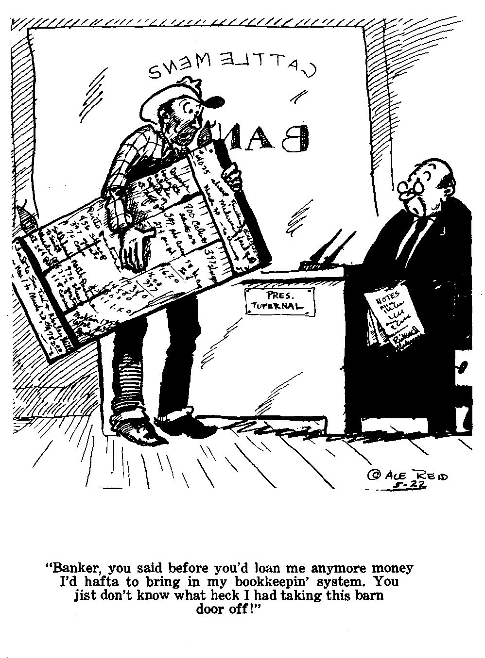

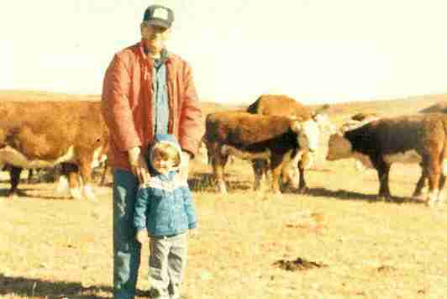

Chester Elvin Vandament died on January 24th, 2007 at Salina, KS. He was the son of Chester E. and Eva Mitchell Vandament. He was born at Covert, KS on February 18th, 1926. He went to school in Covert until his senior year when he attended Osborne High School and he played basketball. He married Joe Ann Boultinghouse on May 5th, 1950.

He is survived by his wife Joe Ann and sons Mitch E. and wife Vickie and Max J. Vandament, grandchild Ryan Michael Vandament and nephews Ervin Dixon and Delvin Dixon. He was proceeded in death by his parents and sisters Charlotte Dixon, Dora Sitts and Dorretha Thornton. He was a Farmer Stockman his entire life. He was an office manager at J-J Oil Co, Woodston, KS for over 30 years and retired in 1989. He had an interest in Quality Fuels Co. Inc and he and the family owned JE System, V&V Vending and JAVCO, Inc.

He will be laid to rest in Osborne Cemetery on Saturday, February 10th, 2007 at 11:00 am, with Reverend Kent Naylor presiding. Memorials may be made to the Rebecca Morrison House in Salina, Kansas or the KU Endowment Fund.

Appreciation
On behalf of the family, we wish to express their gratitude for your kindness evidenced in thought and deed and for your presence at this service. Cowpoke cartoon by Ace Reid. “One Last Look” poem is by Baxter Black.

